

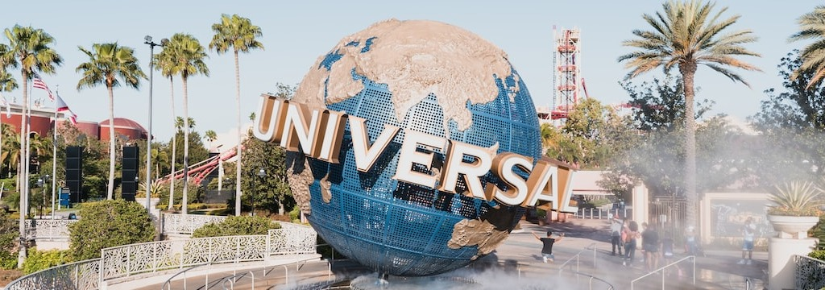

**ICIT 2023 Special Session Proposal**

**Title of the Proposal:**

**Technical Outline of the Session and Topics:**

Outline of the Session:

Topics of the Session:

* *Topic 1*
* *Topic 2*
* *…*

**IEEE IES Technical Committee Sponsoring the Special Session (if any):**

**Short bio and contact details of the Session Organizers**

* *Organizer 1:*
* *Organizer 2:*
* *Organizer 3:*